Ravan Muradzada
Contents
Task 1 1
Download Package 1
Registration 1
Pulling Image and Creating Container 2
Container Log 3
Checking From Browser 3
Task 2 3
Task 3 4
Task 4 4
System Wide 5
User-Specific 5

Task 1

Download Package
The package name is `container-tools`:
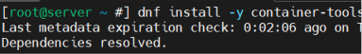

Registration
Let’s register with RedHat account. I have already an account in registry.redhat.io.
So, I will use its credentials here:
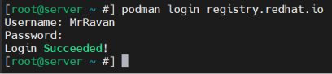
I can also register with docker.io:
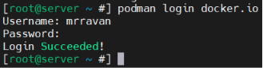

Pulling Image and Creating Container
We can use `pull` command to pull the package:
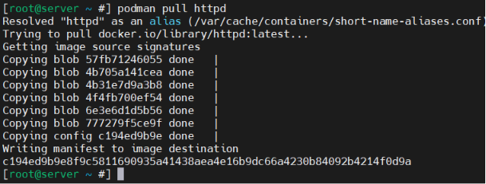
We can view:
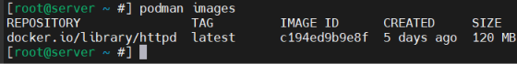
Let’s create a container from the image:
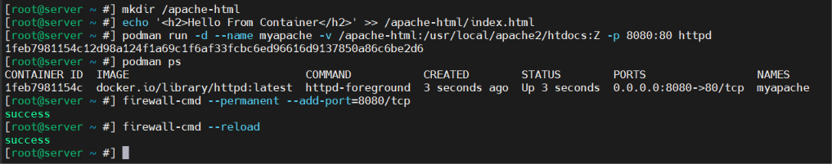
I mounted our container directory (/usr/local/apache2/htdocs/ - This is default directory in debain/ubuntu for html files) to /apache-html in VM. Give it myapache as a name. Moreover, I implemented port forwarding. Mentioned SELinux with :Z. At last I have added port 8080 to firewall.
When we check with podman ps, it shows container is up.

Container Log
We use `podman logs` to see the container logs:

Checking From Browser
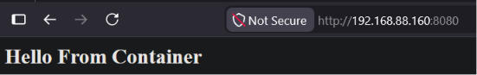

Task 2
We use `exec -it` to switch container’s terminal. Here, `uname -r` shows kernel version. I have printed `/etc/os-relase` additionally:
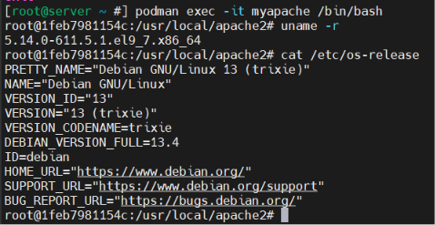

Task 3
Let’s create a volume and pull the image:
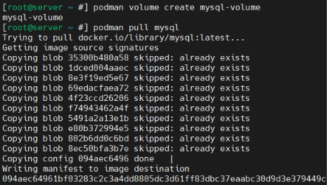
Let’s create a container and view it:
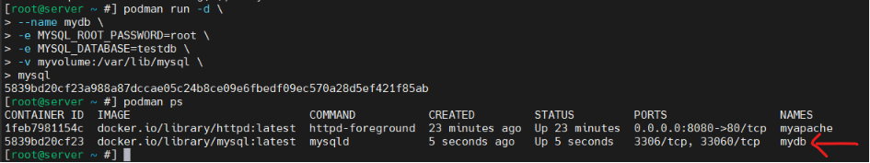
MySQL stores its data in /var/lib/mysql inside the container, so that is why I mount here.

Task 4
It is possible to give 2 kinds responses here. First, we can set this service for full system, so, whenever any user logs in, the service will run. This can be created only by root.
Second, we can create a service file for a specific user, so, whenever this specific user logs in, the service will run.

System Wide
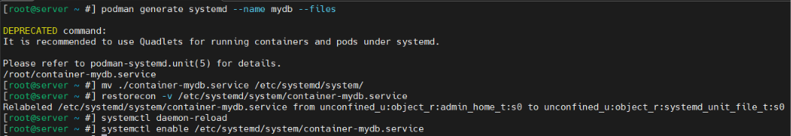
Basically I have created service file using `podman generate system`. Then I moved it `/etc/system/system/`, so that makes it system wide. I have used `restorecon -v`, because when I moved it to the other place, it did not get correct label, so error occurred. It is good to run `daemon-reload` after each unit creation or modification. At last, I just enabled it.

We can verify that by checking the container status with `podman ps` after the reboot:
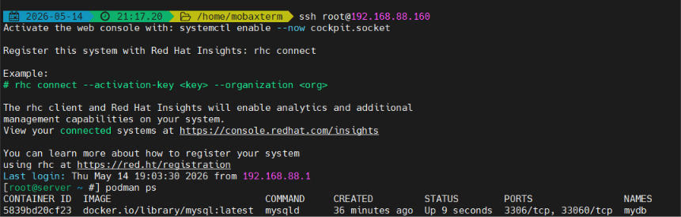

User-Specific
The process is simpler if we create a service user specific.
First, I remove the previous service (system-wide) to prevent confusion:
Let’s remove the container and image to start from scratch:
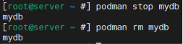
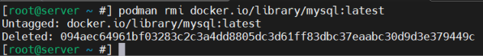
Let’s create a new user. Then create a directory for him to use in mounting process. Then let me make him the user and group owner of the directory. Then give write permission to others (recommended). At last, let’s use loginctl to allow the process we will do below.
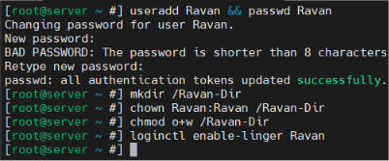
Let’s break our ssh connection (using `exit` command) and reconnect as new user:
In that stage we can `podman login` if it is required as the task 1 above. I do not need it right now.
Let’s create a container after pulling image:
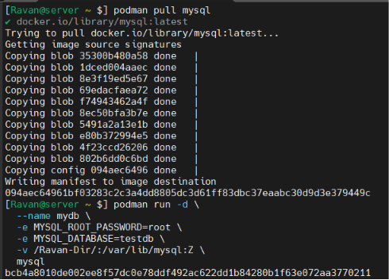

Let’s create a directory for the service file and switch to there. Then create a service file using `podman generate` command:
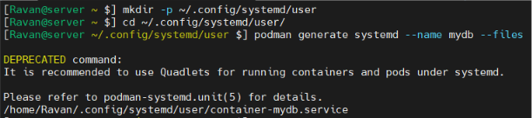
It is good to use `daemon-reload` after creating a new unit. We should enable the service file to make it work properly after the reboot:
Let’s check it. So, when we connect with ssh as Ravan user, the container should be up:
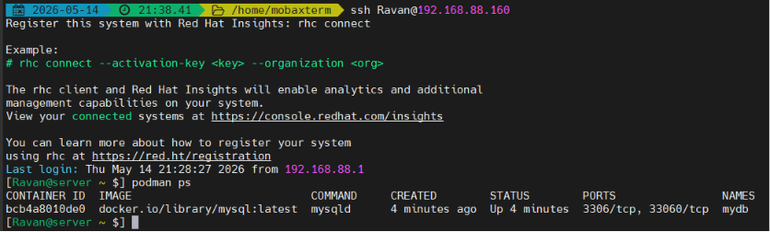
Moreover, it should not work when we log in as another user like root:
